**Flight Booking System UI using Angular**

1. **Home page:**

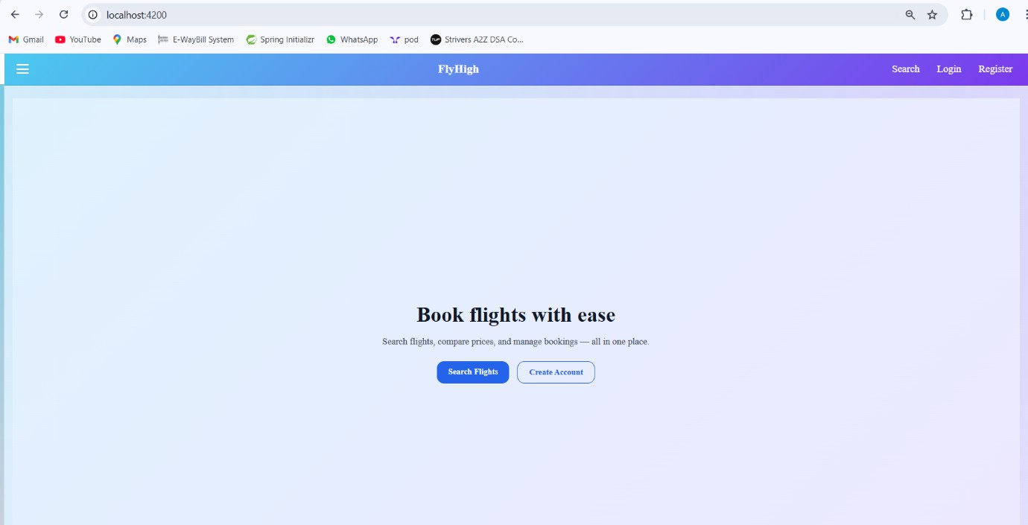

1. **Hamburger menu**:

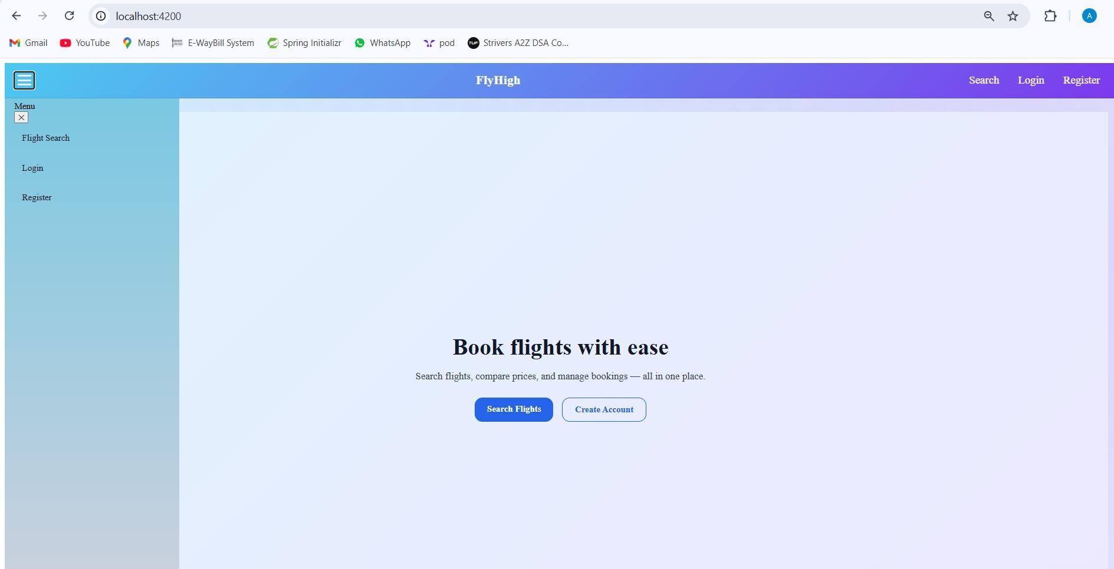

1. **Register Validations**(all fields are required)

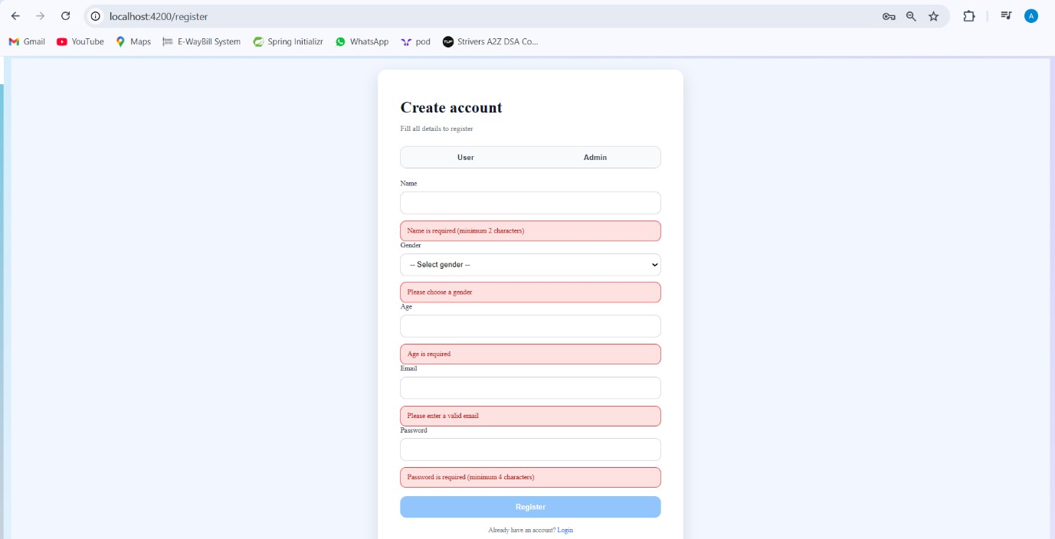

1. **Register Validation :**
   * **Name:** minimum 2 characters
   * **Age:** must be greater than 0
   * **Email:** must be a valid email format
   * **Password:** minimum 4 characters

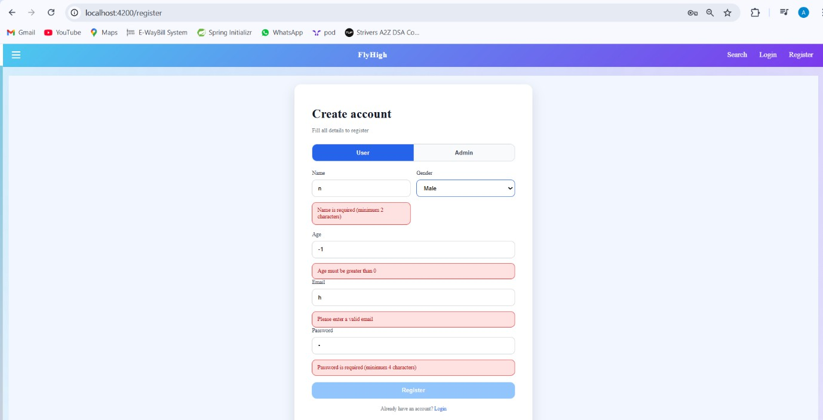

1. **User already exists validation**:

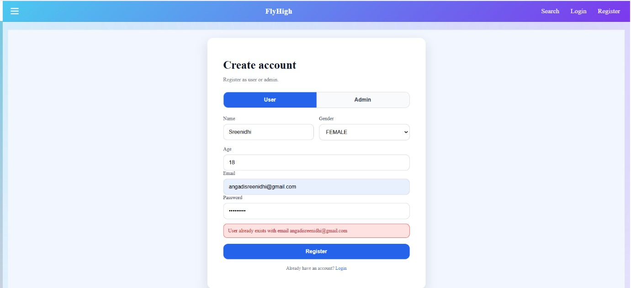

1. 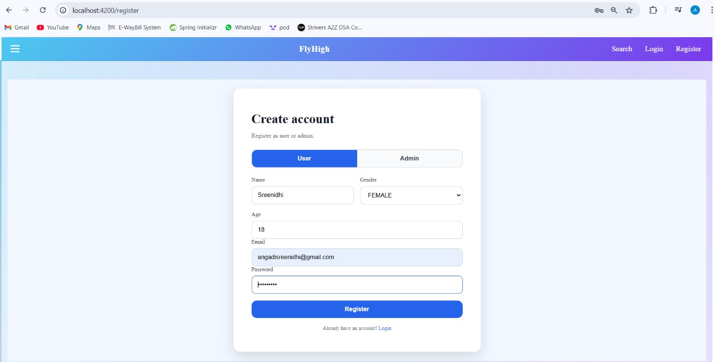Successful Registration:
2. **Login Validation**(all fields required):

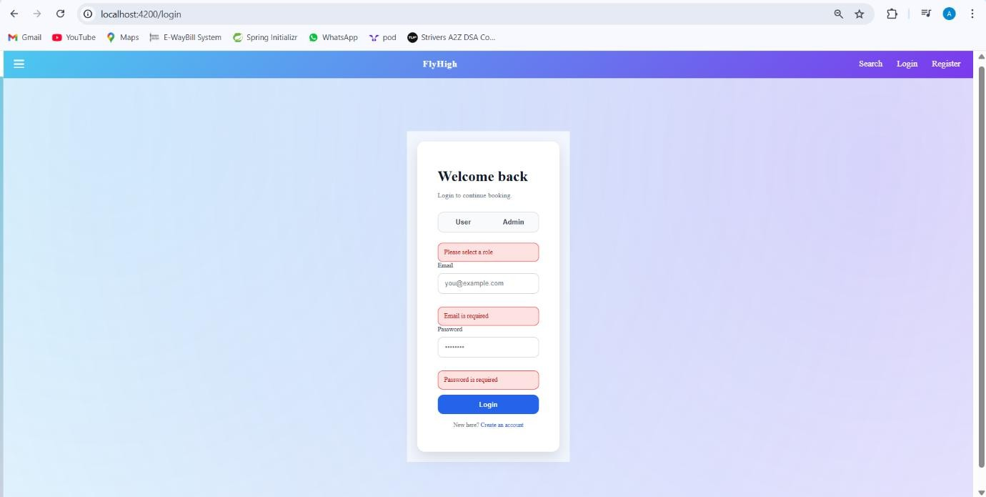

1. **Login Validation** (User/Admin Not Found)

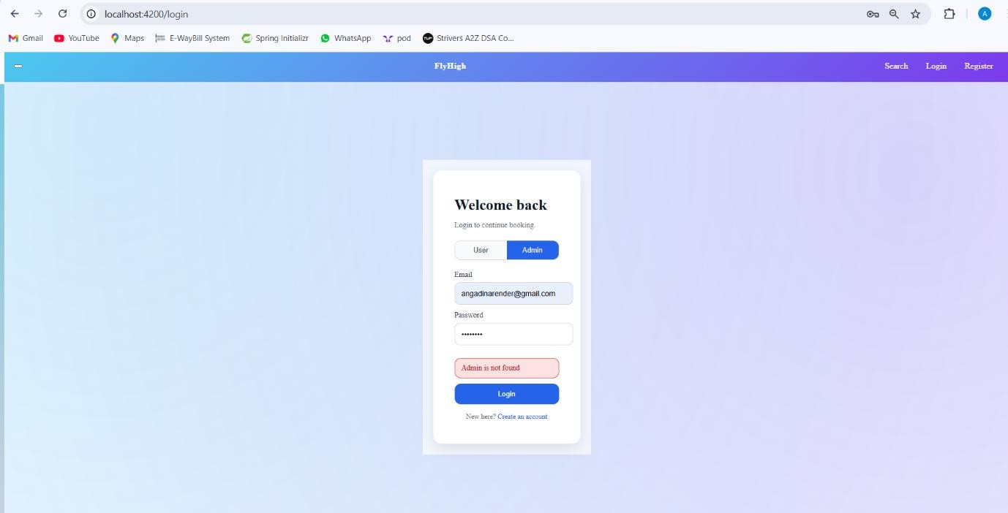

1. **Successful Login**:

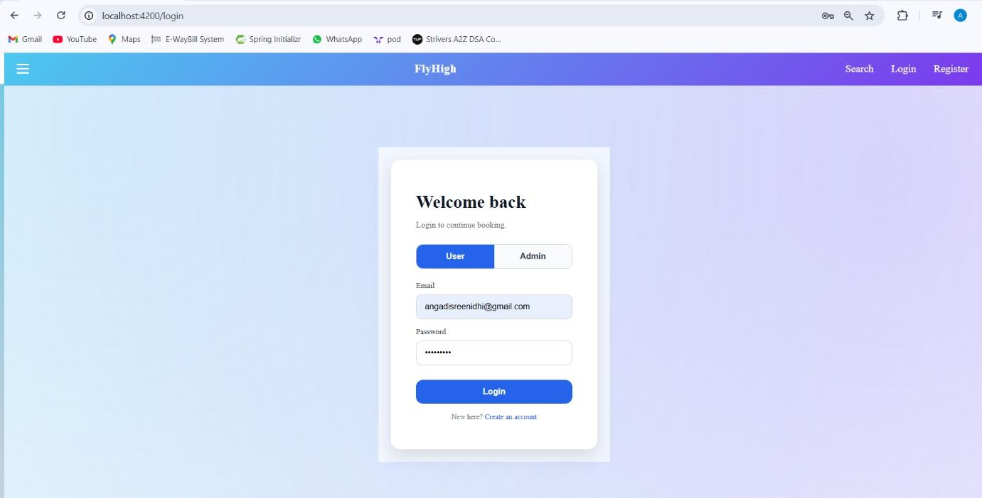

J)**Search Flights**:

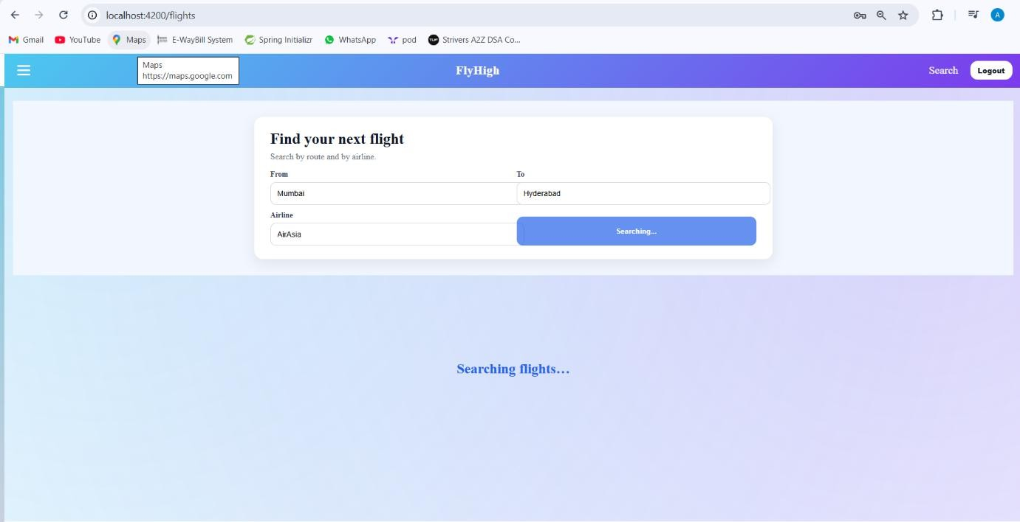

k)**No flights found**:

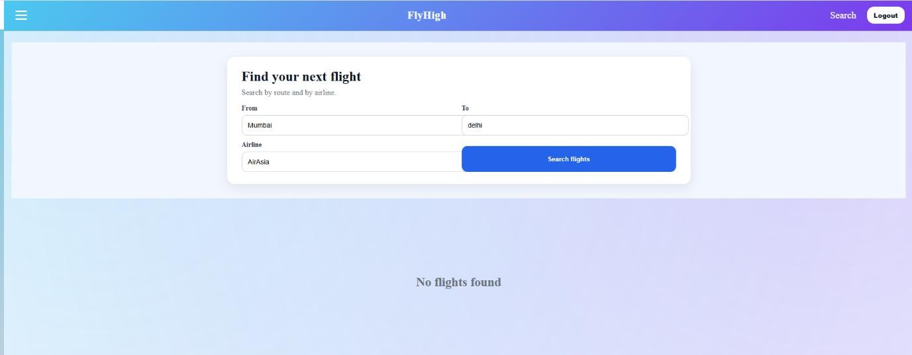

1. **Successful flight search**:

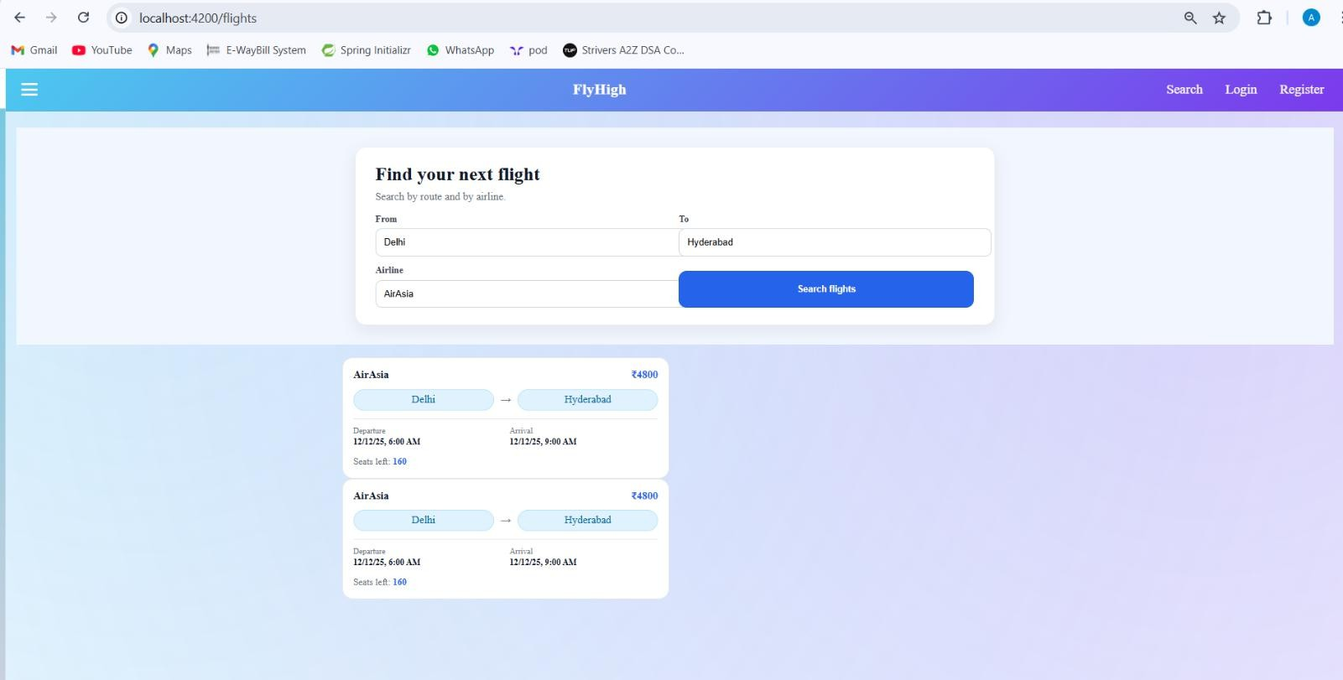

Eureka

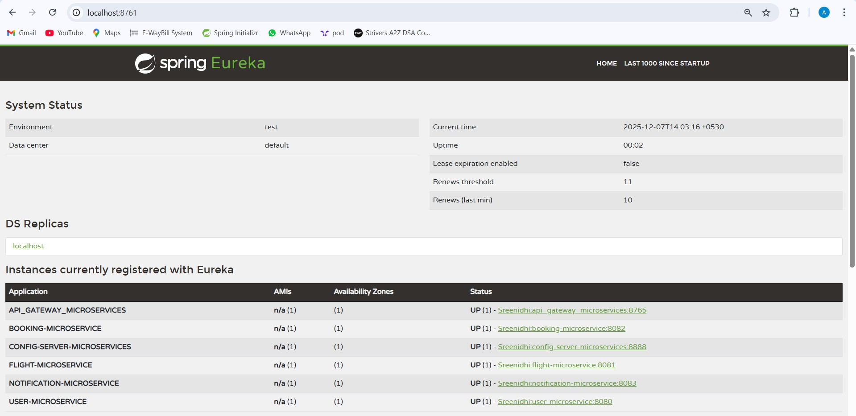

Email Notification a)Booking

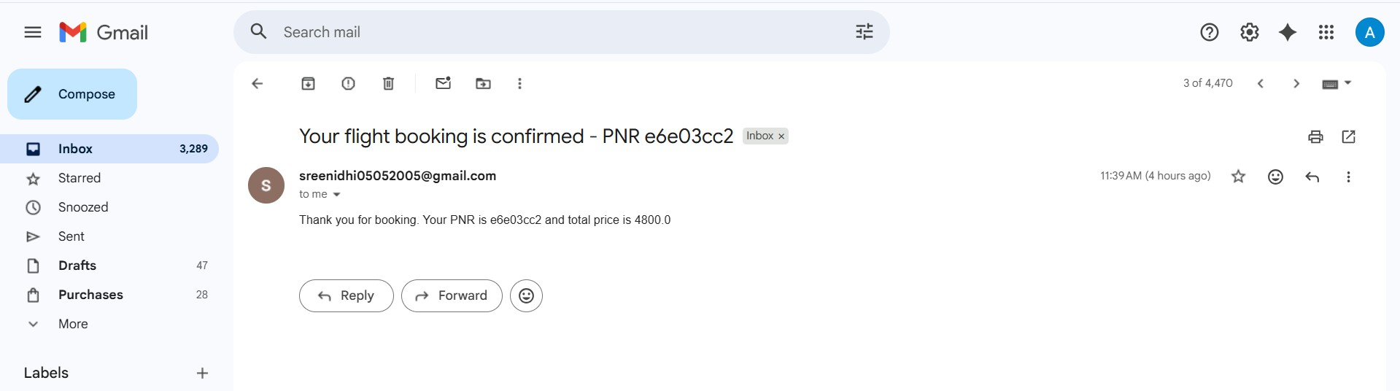

b)cancellation

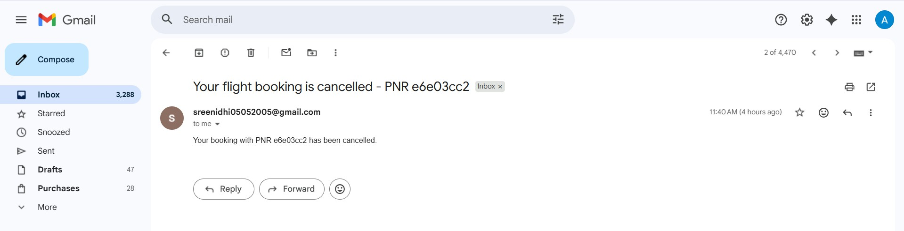

**Docker services and logs**

# Docker desktop working

**Docker log files**

* 1. **To list the containers command :** docker ps

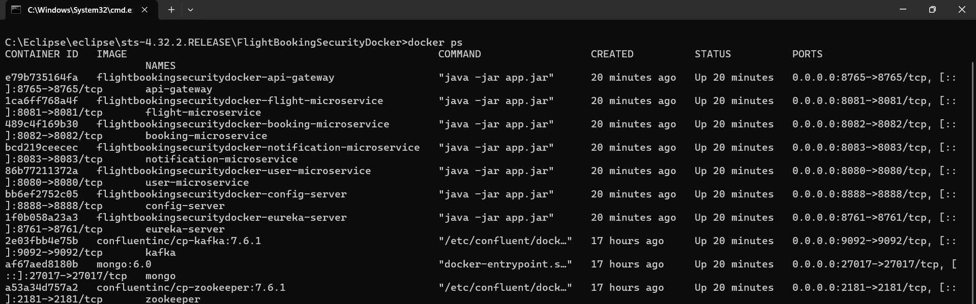

# Eureka Server Logs

**command:** docker logs -f eureka-server

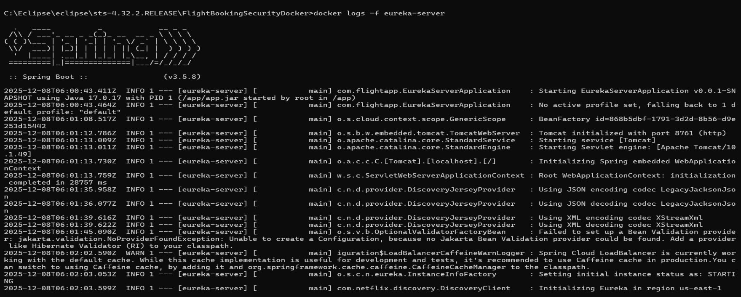

# Config Server Logs

**command**: docker logs -f eureka-server

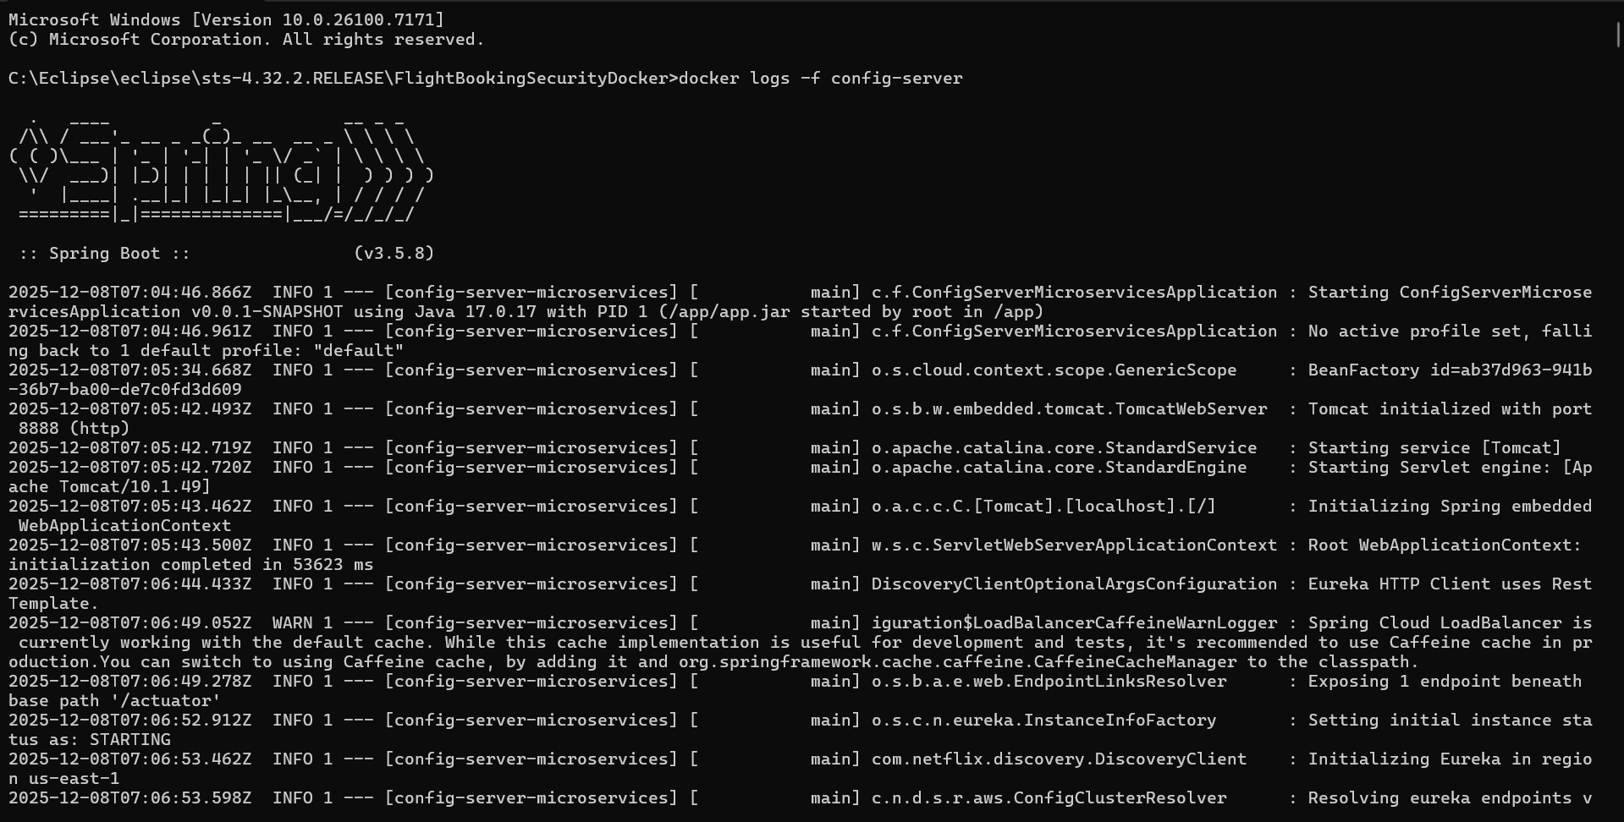

* 1. **API Gateway Logs**

**command: docker logs -f api-gateway**

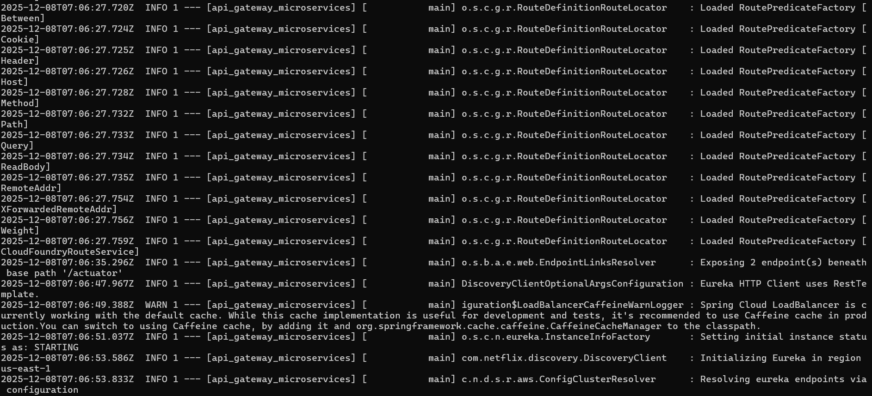

* 1. **User Microservice Logs**

**command**: docker logs -f user-microservice

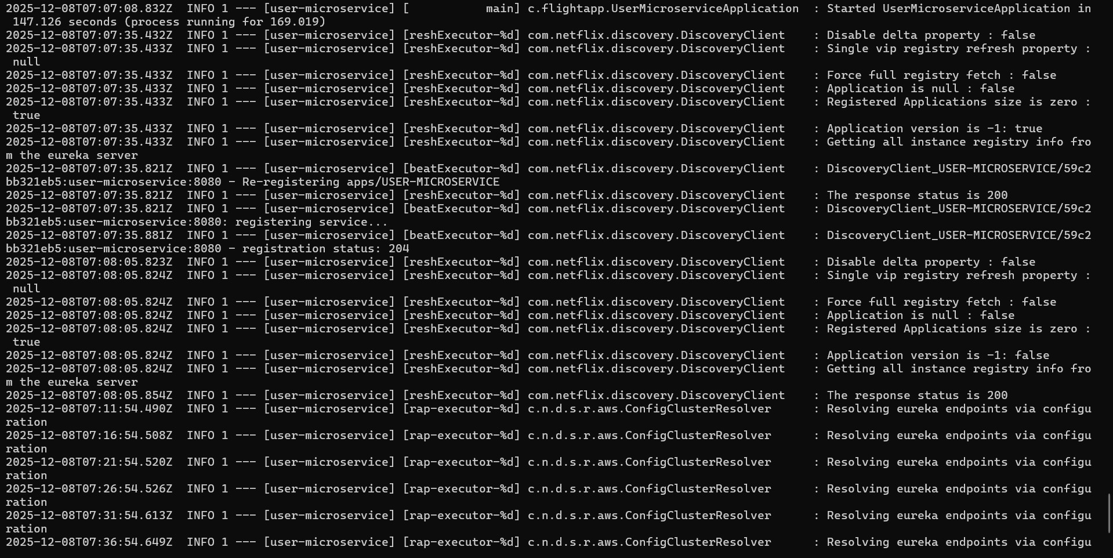

# Flight Microservice logs

**command:** docker logs -f flight-microservice

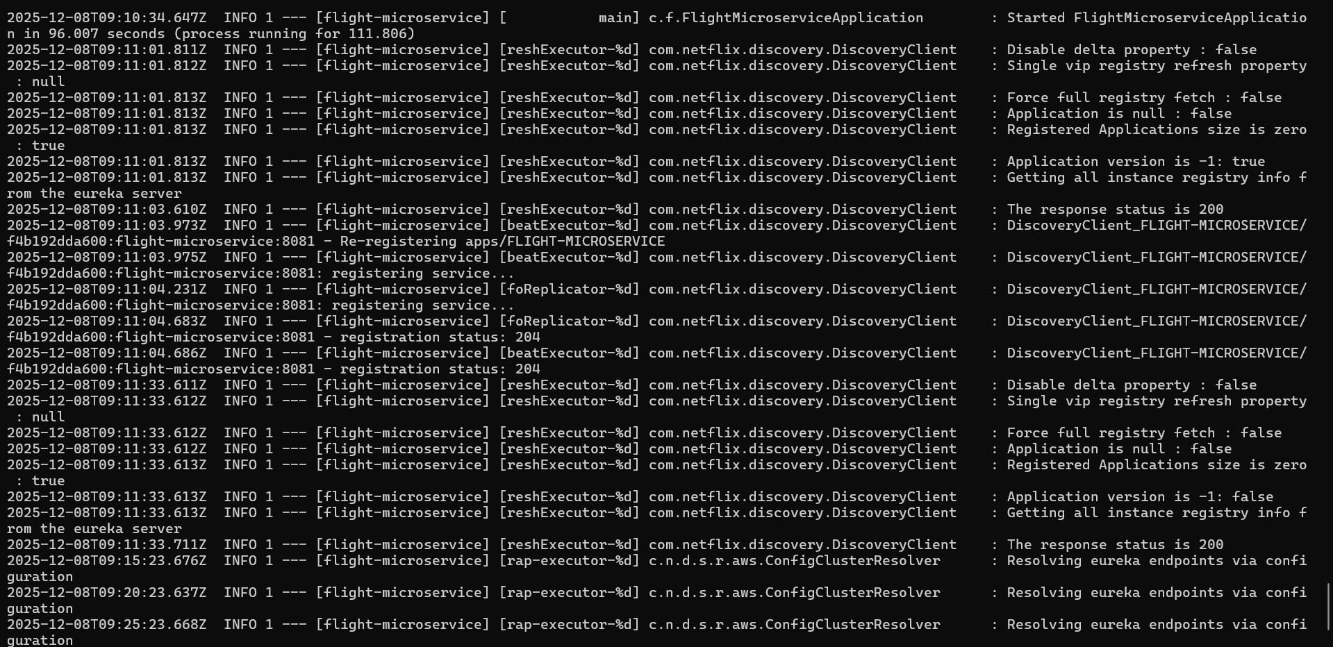

# Booking Microservice logs

**command :** docker logs -f booking-microservice

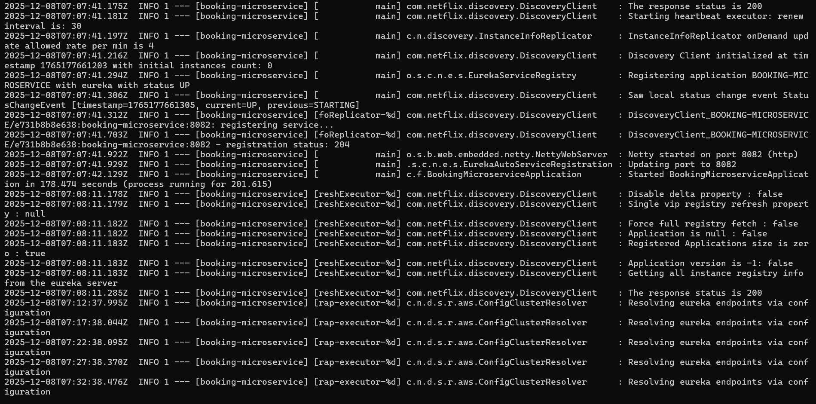

# Notification Microservice Logs

**command :** docker logs -f notification-microservice

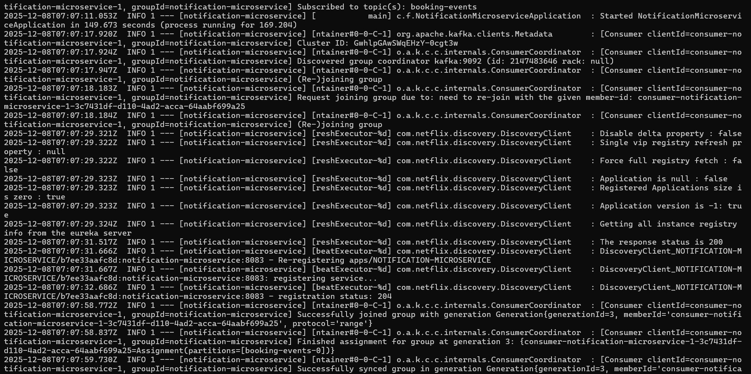

# Kafka Bash

**command:** docker exec -it kafka bash

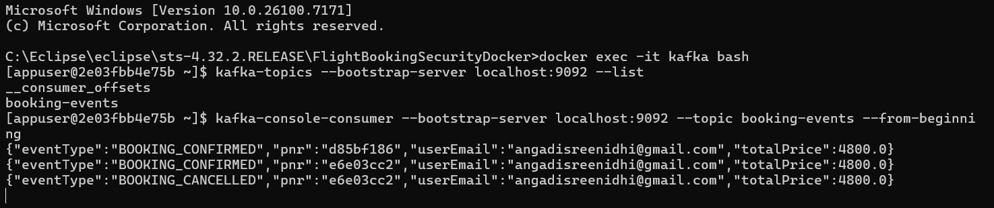

# Mongo

**command:**db.user.find()

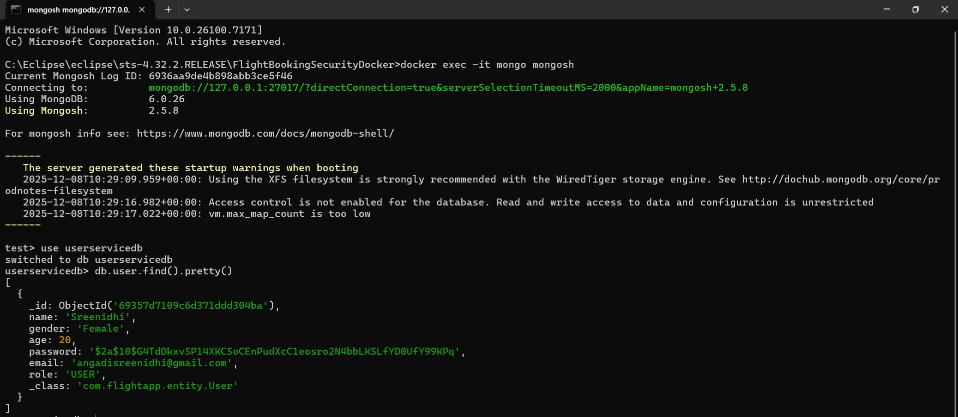

Tickets:

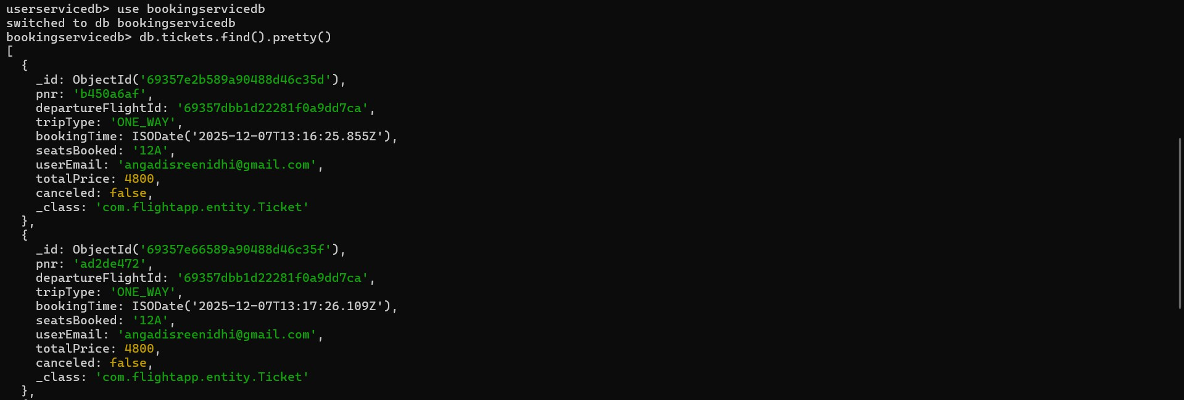

# Postman implementation after Api gateway Security and Dockerization

1. 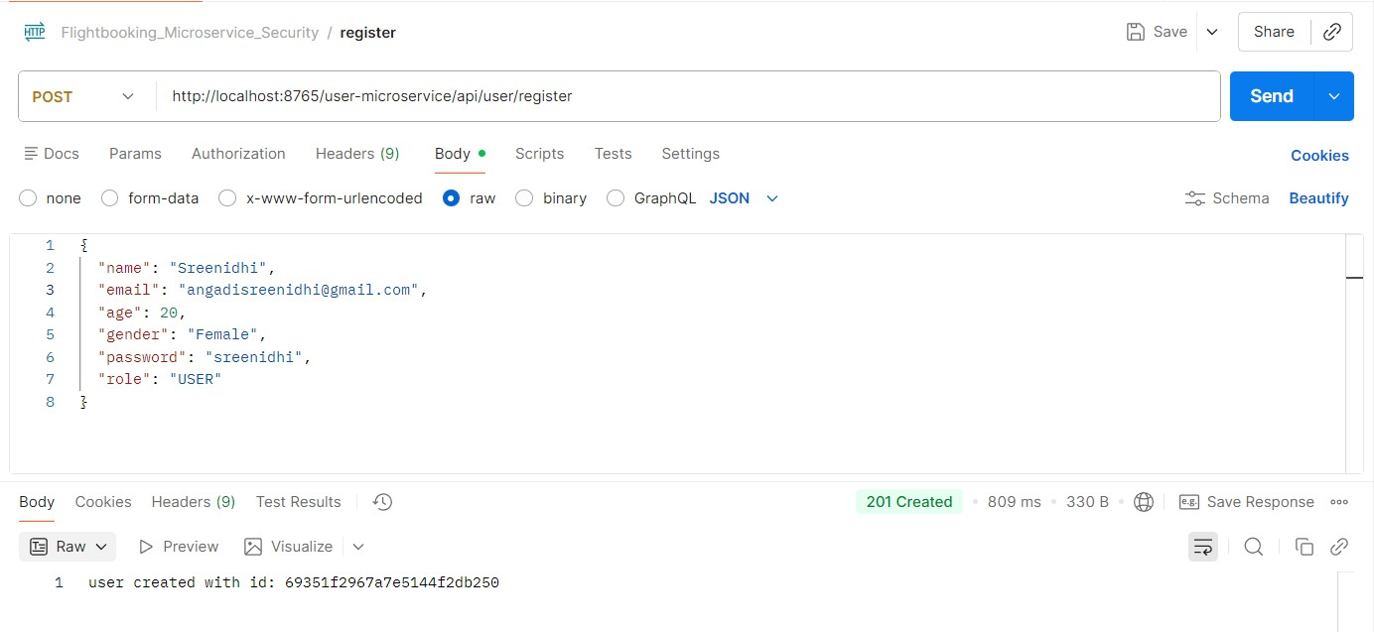user register
2. user already exists validation

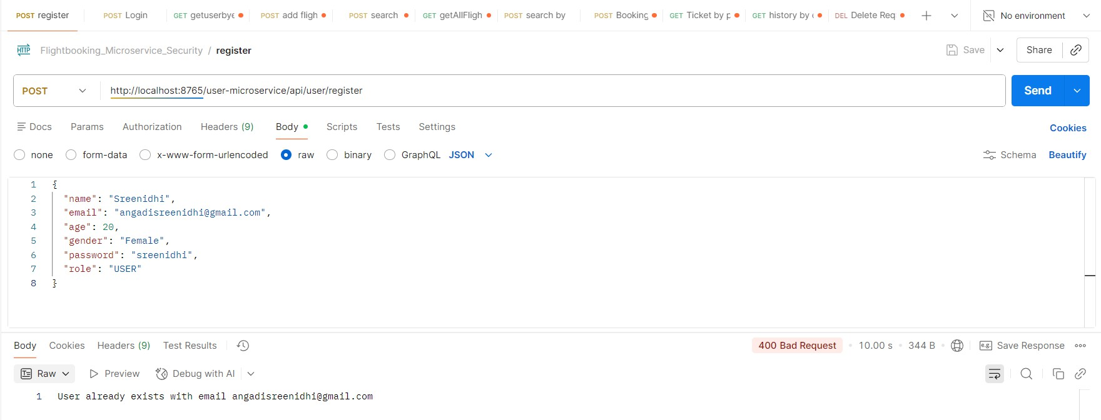

1. User login

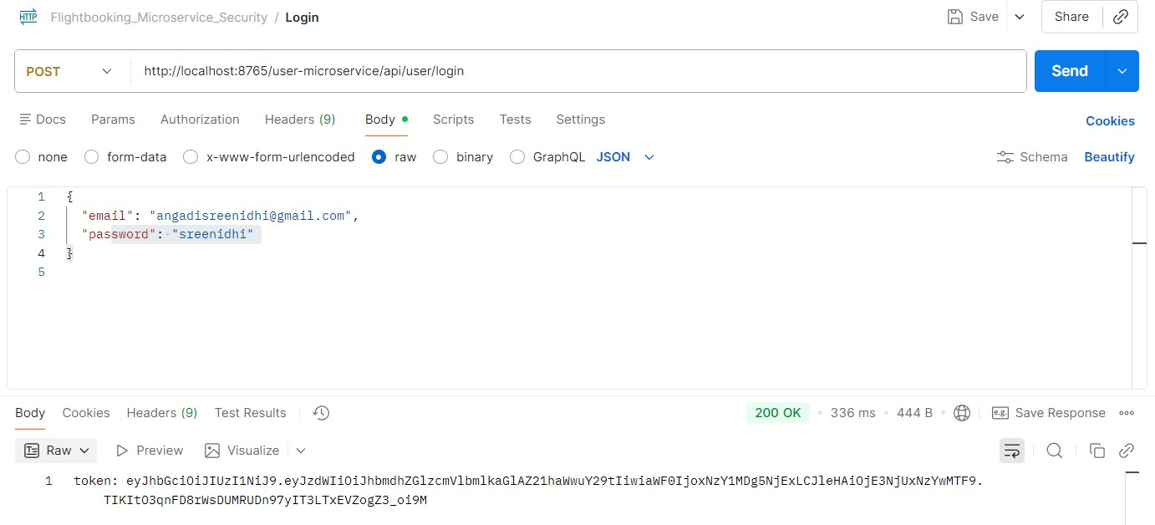

4)Search by airline

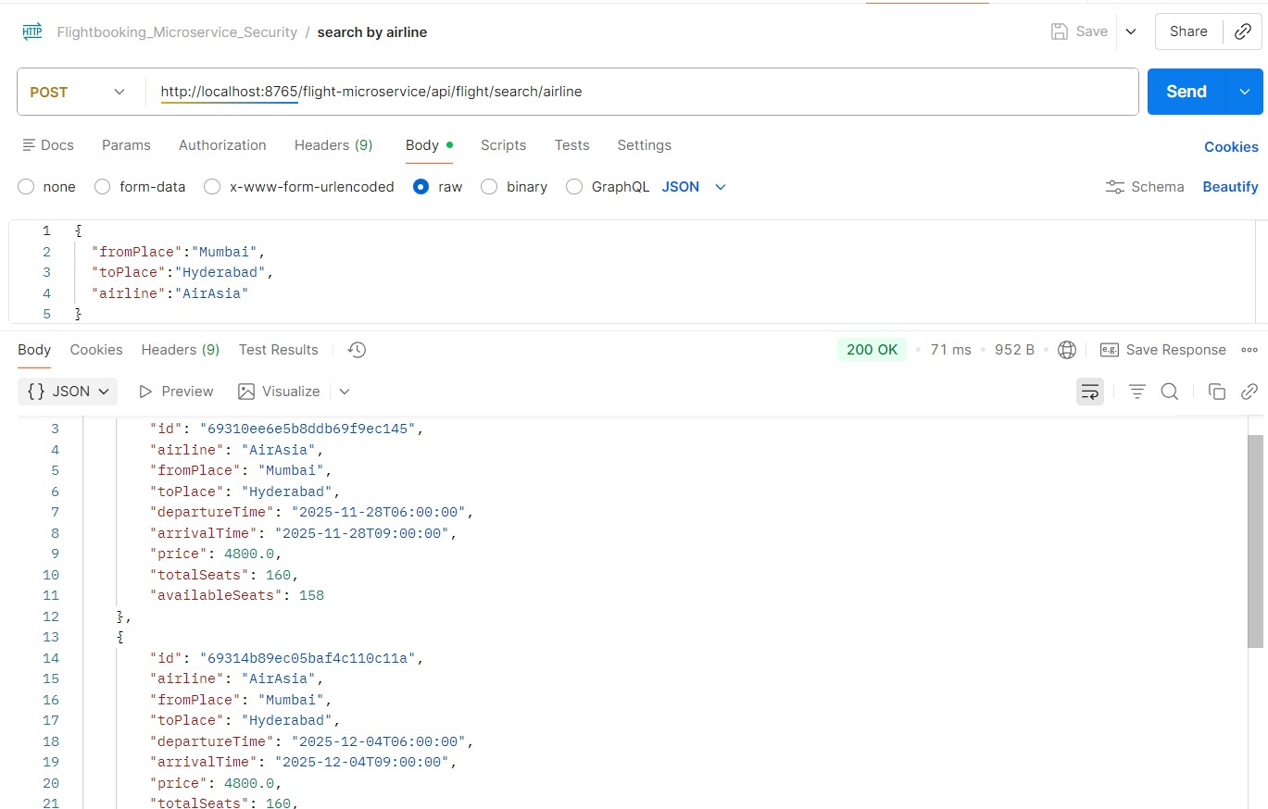

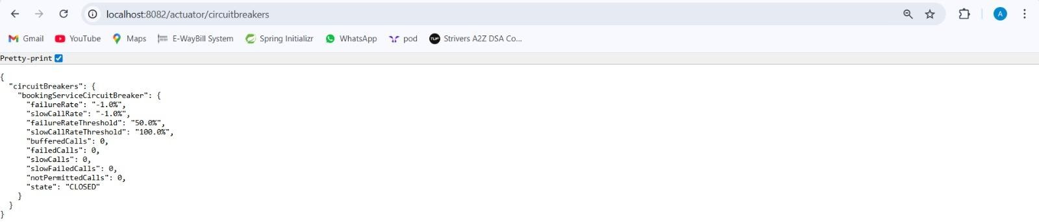**Circuit Breaker**

Config-Server

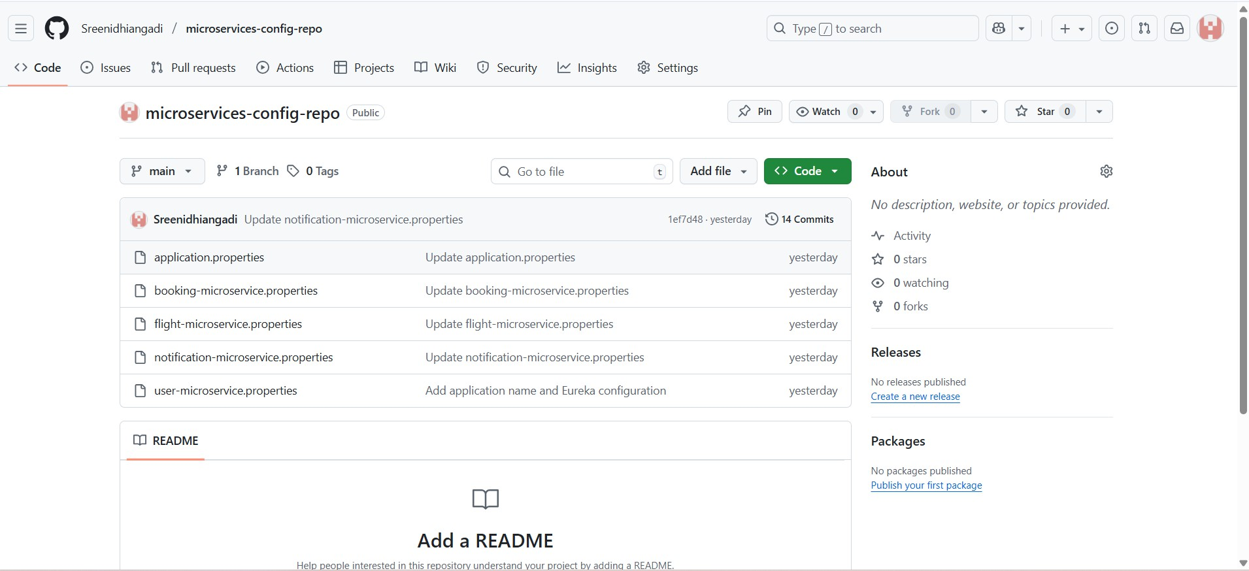

**Jacoco Reports**

1. **Notification_Microservices**

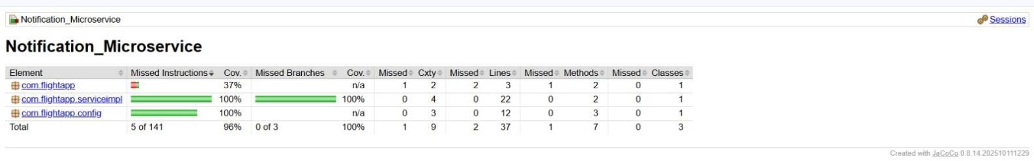

1. **Flight_Microservices**

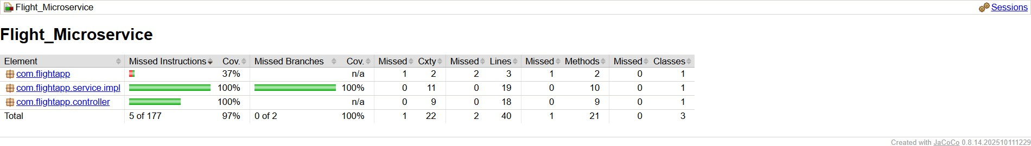

1. **User Microservice**

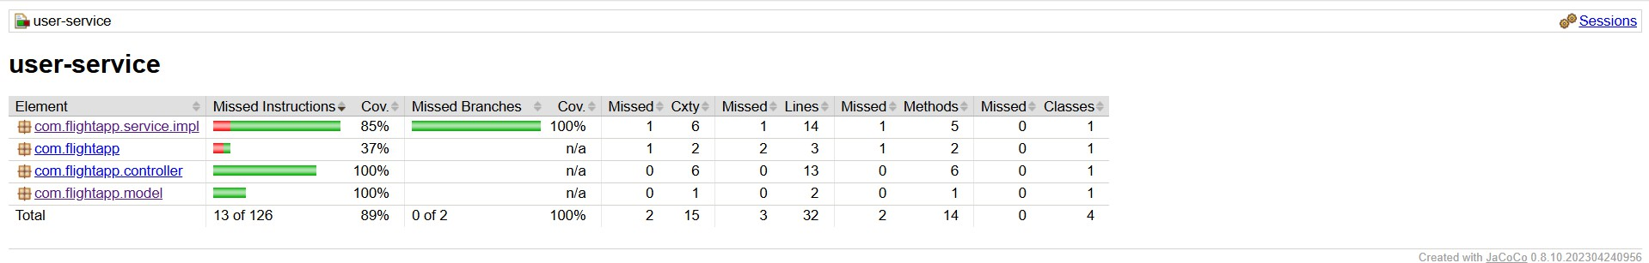

1. **Booking Microservice**

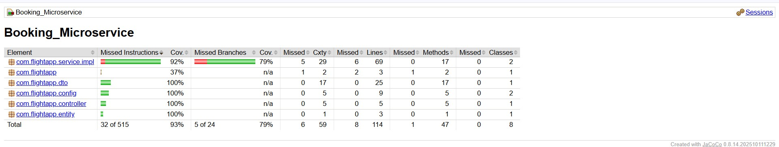

**SONAR Report(Code Coverage)- FlightBookingMicroservices a)Notofication_Microservices**

**Before:**

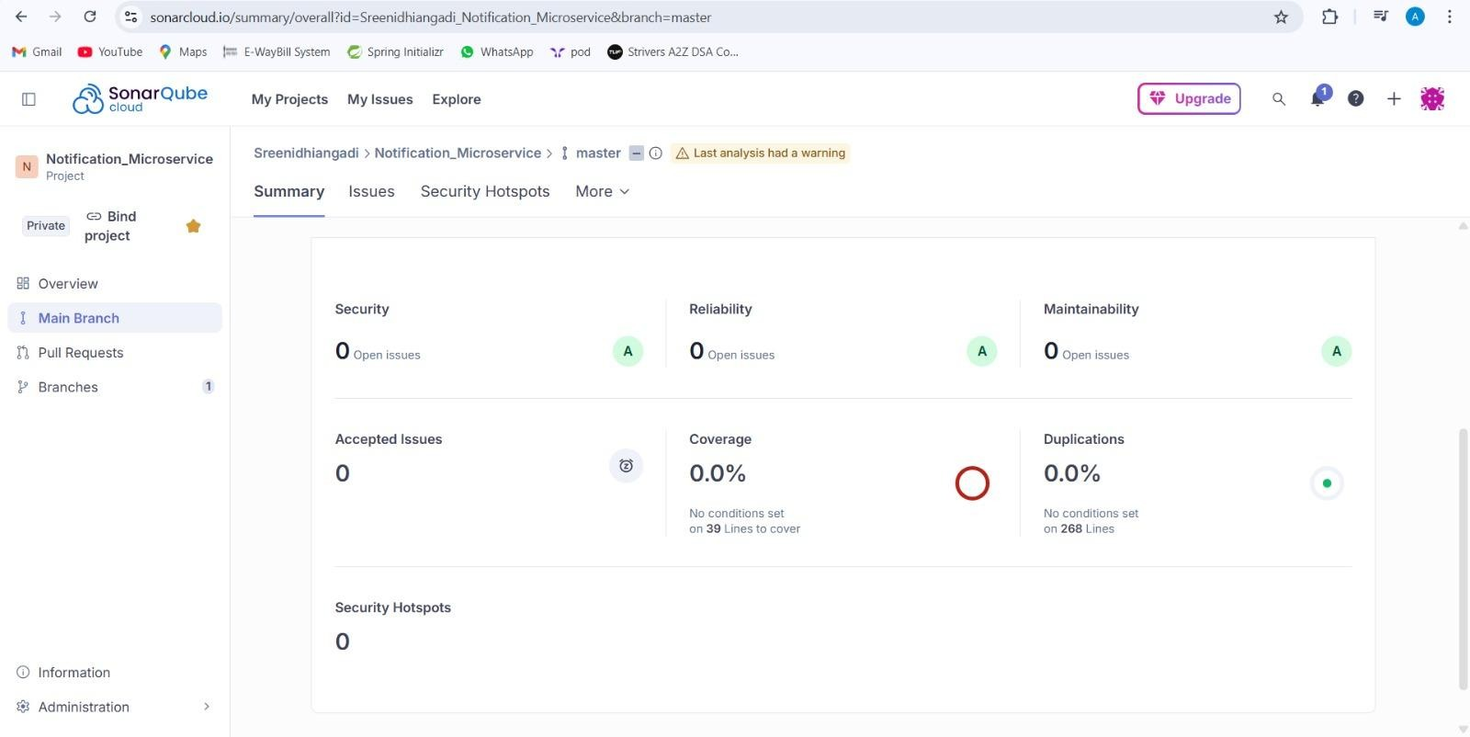

**After:**

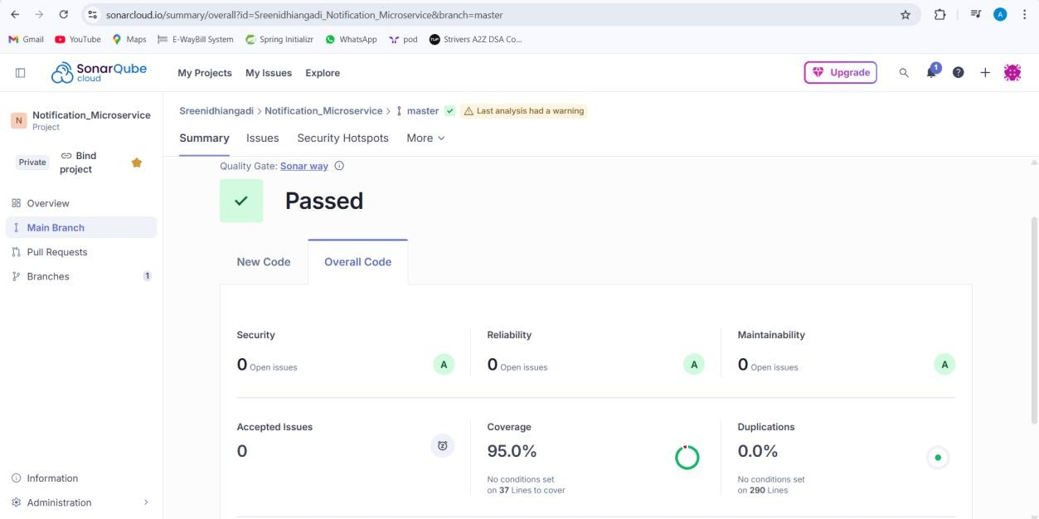

* 1. **Flight_Microservices After:**

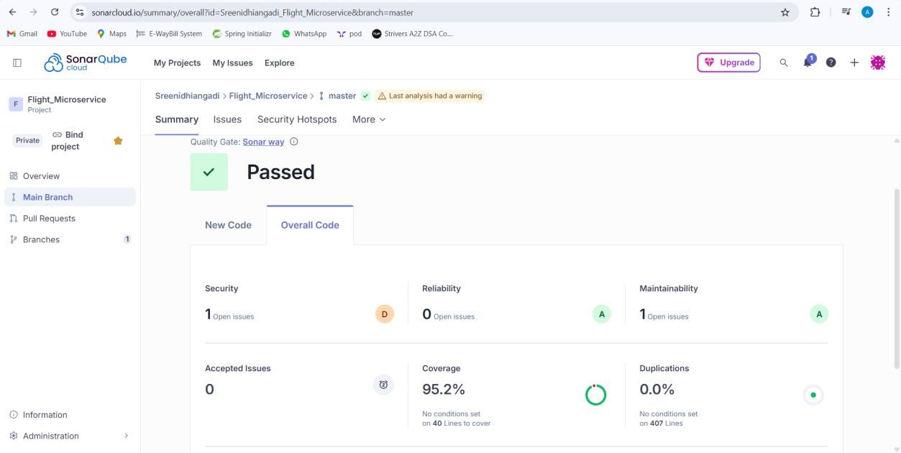

* 1. **User_Microservices Before:**

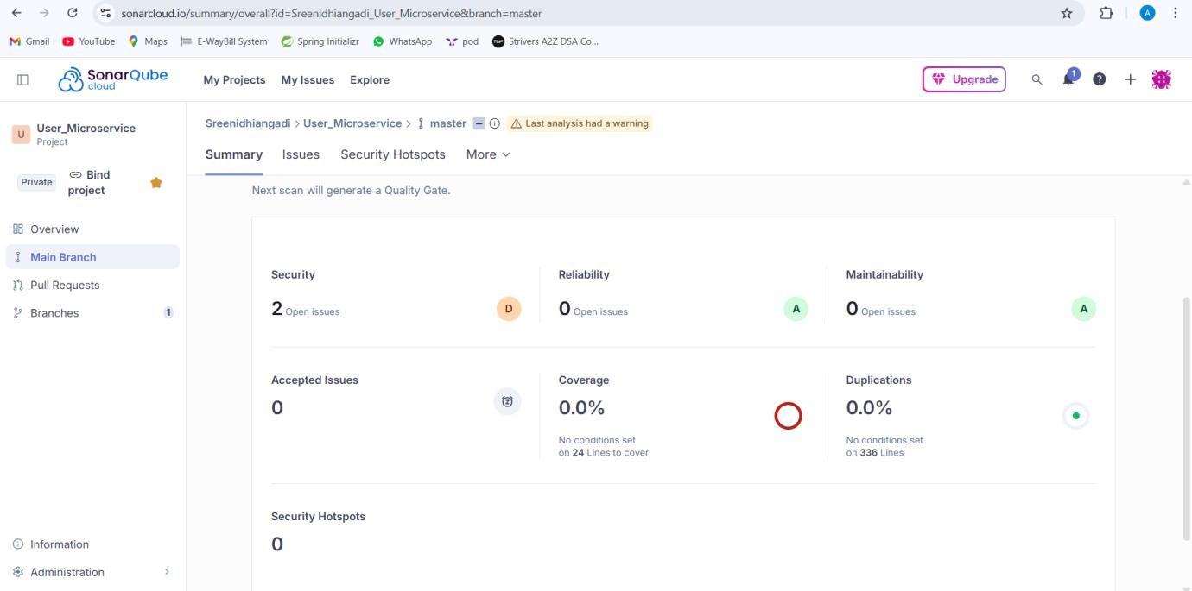

**iii)After:**

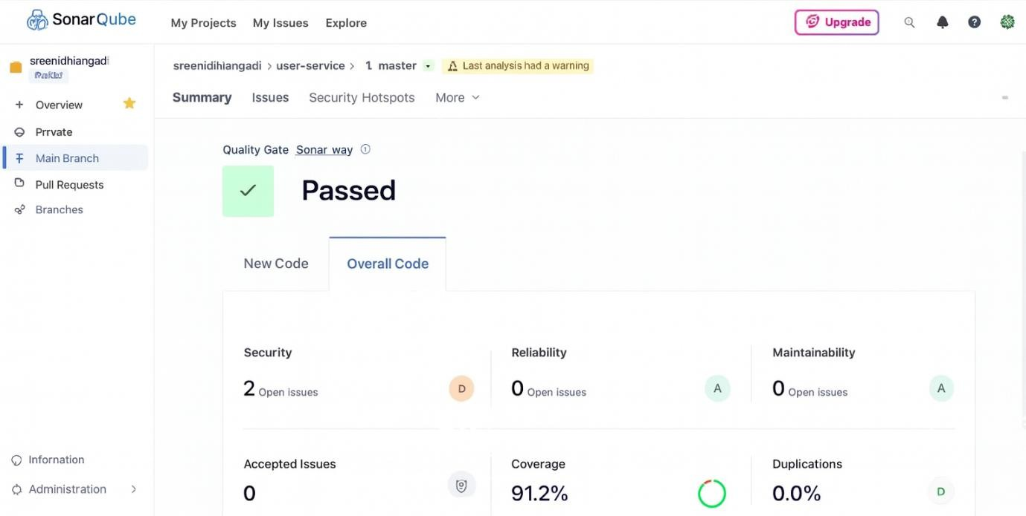

* 1. **Booking_Microservice Before:**

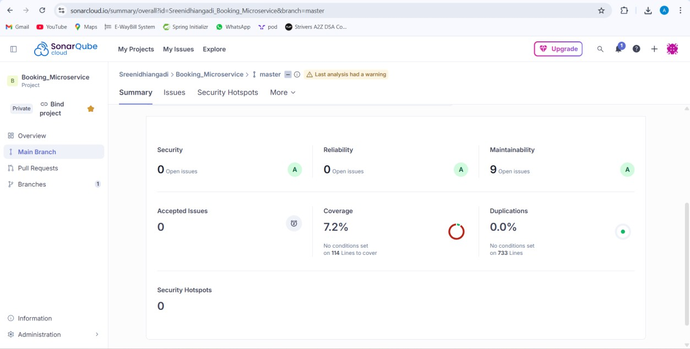

**After:**

